Arrays – Element by Element

# Part I

You do not need to turn anything in for this part of the assignment (but it is in your best interest not to skip this as you will find out in part II)

Fill in the table of built in MATLAB functions for analyzing arrays. Use google or the MATLAB help to find them all.

|  |  |  |
| --- | --- | --- |
| **Function** | **Description** | **Example of how to use** |
|  | Returns the number of elements in vector A |  |
|  | Returns a row vector [m,n], where m and n are the size *mxn* of the array A |  |
| mean(A) |  |  |
|  | If A is a vector, C is the largest element in A. If A is a matrix, C is a row vector containing the largest element of each column of A. |  |
|  | If A is a vector, d is the largest element in A and n is the position of the element (the first if several have the max value). |  |
| min(A) |  |  |
| [d,n] = min(A) |  |  |
|  | If A is a vector, returns the sum of the elements of the vector |  |
| sort(A) |  |  |
|  | If A is a vector, returns the median value of the elements of the vector |  |
| std(A) |  | >> A = [5 9 2 4];  >> std(A)  ans =  2.9439 |

# Part II

# Instructions

Complete the array practice problems below by having MATLAB compute them sequentially from a .m file. **Use ; to suppress the values of everything but the answer from the command window**.

Most of the variable names should be given in the problem. If not, name them something that makes sense. Please make sure that you are commenting appropriately and that you are following the problem instructions.

# Problems

1. The coefficient of friction, µ, can be determined in an experiment by measuring the force *F* required to move a mass *m*. When *F* is measured and *m* is known, the coefficient of friction can by calculated by: $μ=\frac{F}{mg},g=\frac{9.81m}{s^{2}}$ 
   Results from measuring *F* in six tests are given in the table below. Determine the coefficient of friction in each test, and the average from all the tests (2 outputs, make sure to comment and label appropriately).

|  |  |  |  |  |  |  |
| --- | --- | --- | --- | --- | --- | --- |
| Test | 1 | 2 | 3 | 4 | 5 | 6 |
| Mass *m* (kg) | 2 | 4 | 5 | 10 | 20 | 50 |
| Force *F* (N) | 12.5 | 23.5 | 30 | 61 | 117 | 294 |

1. For the function $y=x^{2}−e^{0.5x}+x$, calculate the value of *y* for the integer values of *x* using element by element operations. $−3≤x≤3$
2. 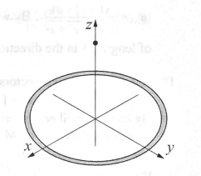The electric field intensity E(z), due to a ring of radius *R* at any point *z* along the axis of the ring is given by $E\left(z\right)=\frac{λ}{2ε_{0}}\frac{Rz}{{\left(z^{2}+R^{2}\right)}^{3/2}}$ 
   where $λ$ is the charge density, $ε_{0}=8.85×{10}^{−12}$ is the electrical constant, and *R* is the radius of the ring. Consider the case where $λ=1.7×{10}^{−7}C/m$ and *R = 6 cm*
   1. Determine $E\left(z\right)$ at *z =* 0, 2, 4, 6, 8, and 10 cm.
   2. Determine the distance *z* where *E* is maximum. Do it by creating a vector *z* with elements ranging from 2 cm to 6 cm and spacing of 0.01 cm. Calculate *E* for each value of *z* and then find the maximum *E* and associated *z* with MATLAB’s built in function max.
3. 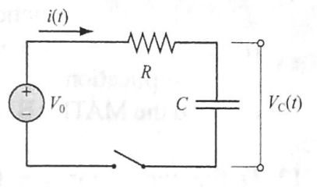The voltage $V_{c}\left(t\right)$ (in V) and the current $i\left(t\right)$ (in Amp) *t* seconds after closing the switch in the circuit shown are given by $V_{c}\left(t\right)=V_{0}\left(1−e^{\frac{−t}{τ_{0}}}\right)$ $i\left(t\right)=\frac{V_{0}}{R}e^{\frac{−t}{τ_{0}}}$ 
   Where $τ_{0}=RC$ is the time constant. Consider the case where $V_{0}=24$ V, $R=3800$ Ω, and $C=4000×{10}^{−6}$ F. Determine the voltage and the current during the first 20 s after the switch is closed. Create a vector with values of times from 0 to 20 s with spacing of 2 s, and use it for calculating $V_{c}\left(t\right)$ and $i\left(t\right)$. Display the results in a three-column table where the values of time, voltage, and current are displayed first, second, and third columns, respectively.